**Aim:**

**Physical Computation of different switch interfacing with Raspberry Pi and LEDs.**

**Objectives:**

1. Introduction to different types of switches and explore the **concept of Pull-up and Pull-Down mode** of a switch.
2. Familiarization with push button and **reading a button** (in both Pull-up and Pull-Down mode) using Micro-Python Script.
3. Controlling an LED with button using **external Pull-Down resistors**.
4. Controlling an LED with button using **internal Pull-up and Pull-Down resistors.**
5. Implementation of a push button as **External Reset Button.**
6. Controlling an LED using a **Push Button as Toggle Switch.**
7. Controlling an LED and a buzzer using a **transistor** and a Push Button.

**Summary of Experiment - 4 Goals and Outcomes**

By the end of this experiment, students will gain a comprehensive understanding about the use and applicability of Pull-Up and Pull-Down resistors. Besides it will provide a brief idea about how to use the GPIO pins of the Raspberry Pi Pico as digital input pins and interface a push button using MicroPython and Pull-Up and Pull-down resistor.

**Pre-Lab Questionnaire:**

1. Define a Switch. What is the need of a switch in an electronic circuit?
2. What are the different types of switches used in an electronic circuit?
3. What do you mean by POLE and THROW in a switch?
4. What is a relay? What is the function of a relay in an electronic circuit?
5. What is the difference between toggle switch and push button switch/Tactile Switch?
6. Why are there 4 pins in push button/Tactile switch?
7. What are the two types of push button switch?
8. Why are push buttons used instead of switches?
9. What is the difference between pull-up and pull down?
10. What is the difference between pull-up and pull-down resistor?
11. Why are pull up resistors more common than pull down resistors?
12. How do I choose a pull-up resistor? What should be the suitable resistance value for Pull-Up?

**Answers to Pre-Lab Questions**

**Components/Equipment Required:**

|  |  |  |  |
| --- | --- | --- | --- |
| **Sl. No.** | **Name of the**  **Component / Equipment** | **Specification** | **Quantity** |
| 1 | Raspberry Pi Pico | RP2040 microcontroller chip, 125MHz | 1 |
| 2 | Raspberry Pi Pico cable | USB Type A to Micro-B | 1 |
| 3 | Resistors (carbon type) | ¼ watt (330 Ω) | 8 |
|  | ¼ watt (10 kΩ) | 2 |
| 4 | LED | 3mm, Red | 8 |
| 5 | Tactile Push Button Switches | 6 x 6 x 6 mm | 2 |
| 6 | Breadboard | 840 Tie points | 1 |
| 7 | Jumper Wire | --------------------------- | As per requirement |

**Objective 2**

**Familiarization with push button and reading a button (in both Pull-up and Pull-Down mode) using Micro-Python Script.**

**Circuit / Schematic Diagram**

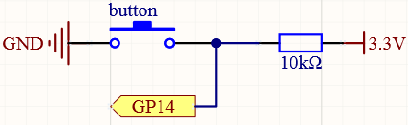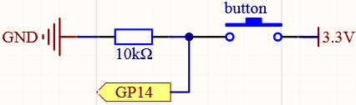

**(Figure 2: Circuit diagram for implementation of reading a button in Pull Up Mode)**

**(Figure 1: Circuit diagram for implementation of reading a button in Pull Down Mode)**

**Objective 3**

**Controlling an LED with button using external Pull-Down resistors.**

**Circuit / Schematic Diagram**



**(Figure 3: Circuit diagram for controlling an LED with button using external Pull-Down resistor.)**

**Code**

**Write a program that controls an LED with button using external Pull-Down resistors.**

**Observation**

**Figure 4: (Simulation-based electronic circuit for implementation of reading a button in Pull Down Mode.)**

**Figure 5: (Hardware implementation-based electronic circuit of reading a button in Pull Down Mode.)**

**Objective 4**

**Controlling an LED with button using internal Pull-up and Pull-Down resistors.**

**Circuit / Schematic Diagram**

**(Figure 7: Circuit diagram for controlling an LED with button using internal Pull-Up resistor.)**

**(Figure 6: Circuit diagram for controlling an LED with button using internal Pull-Down resistor.)**

**Code**

**Write a program that controls an LED with button using internal Pull-up and Pull-Down resistors.**

**Observation**

**Figure 8: (Simulation-based electronic circuit for implementation of an electronic circuit for controlling an LED with button using internal Pull-Down resistor.)**

**Figure 9: (Hardware based electronic circuit for implementation of an electronic circuit for controlling an LED with button using internal Pull-Down resistor.)**

**Objective 5**

**Implementation of a push button as External Reset Button.**

**Circuit / Schematic Diagram**



**(Figure 10: Circuit diagram for implementation of a push button as External Reset Button.)**

**Code**

**Write a program for a push button as External Reset Button.**

**Observation**

**(Figure 11: Simulation based electronic circuit for a push button as External Reset Button.)**

**(Figure 12: Hardware based electronic circuit for a push button as External Reset Button.)**

**Objective 6**

**Controlling an LED using a Push Button as Toggle Switch.**

**Circuit / Schematic Diagram**



**(Figure 13 : Circuit diagram for controlling an LED using a Push Button as Toggle Switch.)**

**Code**

**Write a program for controlling an LED using a Push Button as Toggle Switch.**

**Observation**

**(Figure 14: Simulation based electronic circuit for Controlling an LED using a Push Button as Toggle Switch.)**

**(Figure 15: Hardware based electronic circuit for Controlling an LED using a Push Button as Toggle Switch.)**

**Objective 7**

**Controlling an LED and a buzzer using a transistor and a Push Button.**

**Circuit / Schematic Diagram**

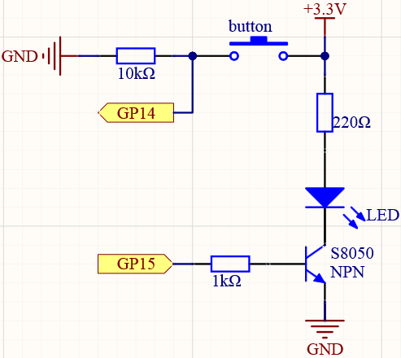

**(Figure 16 : Circuit diagram for controlling an LED and a buzzer using a transistor and a Push Button.)**

**Code**

**Write a program for controlling an LED and a buzzer using a transistor and a Push Button..**

**Observation**

**(Figure 17: Simulation based electronic circuit for controlling an LED and a buzzer using a transistor and a Push Button.)**

**(Figure 18: Hardware based electronic circuit for controlling an and a buzzer using a transistor and a Push Button.)**

**Conclusion:**

|  |
| --- |
|  |
|  |
|  |
|  |
|  |
|  |
|  |
|  |
|  |
|  |

**Precautions:**

|  |
| --- |
|  |
|  |
|  |
|  |
|  |
|  |
|  |
|  |
|  |
|  |

**Post Experiment Questionnaire:**

1. (a) Write how many input and output terminals an SPST, SPDT, DPST, DPDT switch has?

(b) For which condition mechanical switches are more preferable than momentary switch and vice-versa?

(c) For separation of Line and Ground, which mechanical switch is more preferable?

(d) Give a comparison between SPDT and DPDT type of switches.

(e) Identify the switches given below from their symbols/schematics:

(i) (ii) (iii) (iv) (v)

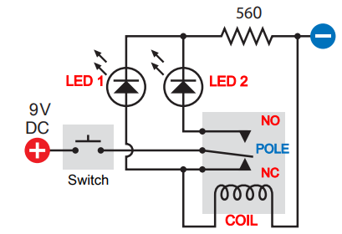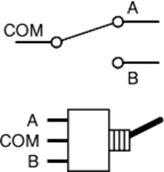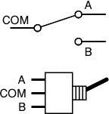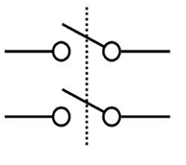

SPST on-off switch symbol

1. Select any one CORRECT answer from the following given choices.

**(a)** A switch has ………………

1. One state
2. Two states
3. Three states
4. None of the above

**(b)** A relay is ……….. Switch.

i) A mechanical

ii) An electronic

iii) An electromechanical

iv) None of the above

**(c)**The switch that has the fastest speed of operation is ………….. switch

1. Electronic
2. Mechanical

(iii)Electromechanical

(iv)None of the above

1. The most inexpensive switch is ………….. switch
2. Electronic
3. Mechanical

(iii)Electromechanical

(iv)None of the above

1. A relay is superior to a mechanical switch because it ……………
2. Is relatively inexpensive
3. Does not require moving contacts

(iii) Combines control with power amplification

(iv)None of the above

1. Can we connect the digital logic pins directly to the Logic level voltage or with the ground like the below image? or any modification is required here. Justify your answer.
2. When should and should not we use a pull-down/pull-up resistor for an input pin?
3. Suppose we have a logic circuit where the Supply source is 3.3V(as in Raspberry pi pico) and the acceptable logic high voltage is 3V, and we could sink a current maximum of 30uA, then calculate the suitable value of pull-up resistor?
4. Suppose we have a logic circuit where the Supply source is 3.3V(as in Raspberry pi pico) and the acceptable logic low voltage is 1V, and we could source upto current maximum of 200uA, then calculate the suitable value of pull-down resistor?
5. Is there a way to detect a long press on a button? For example, let’s say I have one button and two LEDs, long press turns on the second led but short press turns on the first LED.... If so, how can I do it? Justify your answer through your code.
6. Suppose, I have a button, which for some reason fires multiple times when pressed. How can I make the button execute the code just once each time it is pressed? Modify the code below to solve this problem.

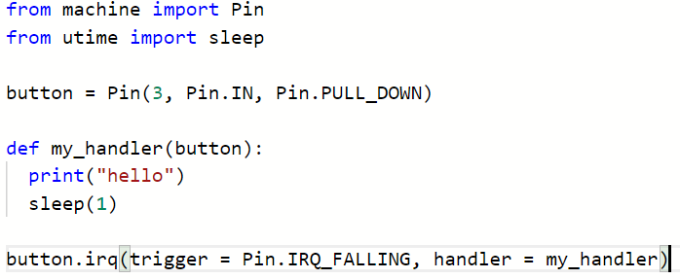

**Answers to Post-Lab Questions**

|  |  |  |  |
| --- | --- | --- | --- |
| **(Signature of the Faculty)** | |  | **(Signature of the Student)** |
|  | | **Name:** |  |
| **Date:** |  | **Registration No.:** |  |
|  |  | **Branch:** |  |
|  | | **Section** |  |
|  | | | | |